The Model YGS 43C offers a fully integrated CNC in one of our most compact options to date. A built in tank allows for this machine to be placed in the smallest of spaces in any shop. The features of this DrillMate allow interactive programming with Real-time Path Display for reliability on program management.

* **Large Standard 20 position Tool Changer**
* **Optional Submerged Work Tank**
* **Touch Screen Operator Control**
* **Windows Operating System**
* **Granite X & Y Axis Column**
* **Compact Internal Tank**
* **Servo Driven Linear Axis**
* **Safety Door Sensors**
* **Programmable W Axis**
* **A & B Axis Interface**

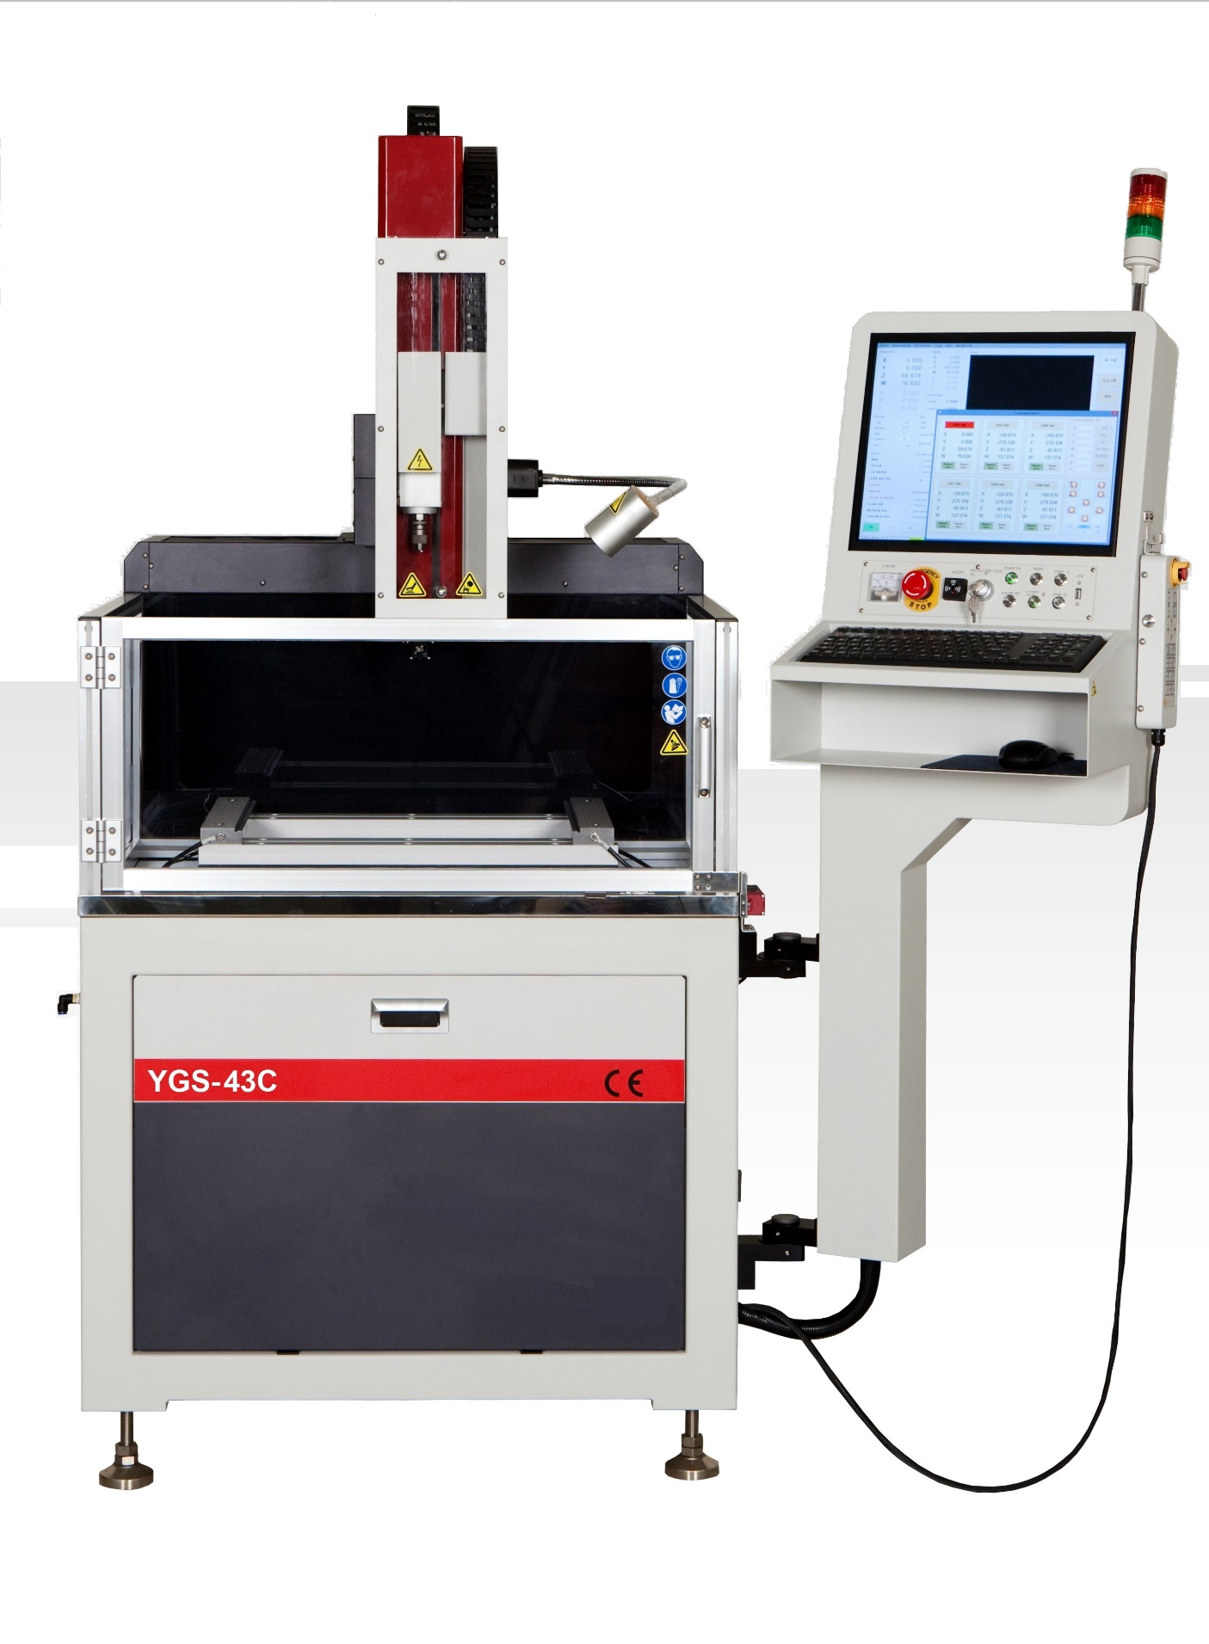

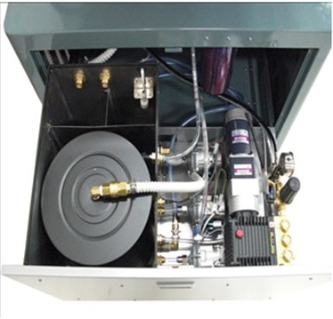

**The tank’s pull out storage makes this our most compact CNC machine to date**

**MACHINE SPECIFICATIONS**

**Table Travel (X-Y)**

**W Axis Stroke**

**Electrode Diameter (w/o AEC**

**Electrode Diameter (w/ AEC)**

**Work Table Size**

**Max Table Size (WxDxH)**

**Max Workpiece Weight**

**Max. Workpiece Height**

**Min Work Height From Table**

**Machine Travel Dimensions**

**Machine Dimensions**

**Machine Weight**

**Shipping Dimensions**

**Shipping Weight**

**Model YGS-43C**

**17.75”x 11.75” X 15.75**

**15.75”**

**0.1 mm – 3.0mm**

**0.3 mm – 3.0mm**

**15.75” x 23.6”**

**26.75”x 36.2”x 16”**

**1100 lbs.**

**15.75”**

**2.5”**

**57” x 59” x 85”**

**59” x 55” x 79”**

**1,650 lbs**

**57” x 59” x 85”**

**3,020 lbs**

POWER SUPPLY/FLUID UNIT

**Voltage Selections**

**Input Voltage**

**Max Current**

**Dielectric Fluid**

**Fluid Capacity**

**Deionize System**

**2 Steps**

**220V 3 Phase**

**65 Amp**

**Water/Oil**

**15 Gallons (Standard)**

**Standard**

**Granite Worktable with T-Slots  
With M8 Threads**

CONTROL

**Input System**

**Display**

**Position Command System**

**Operating System**

**USB/LAN/MDI**

**15” LCD Touch Screen**

**Incremental/Absolute**

**Microsoft Windows 10**

Distributed by PERSEO-ERIE, Inc.

2230 West 23rd Street • Erie, PA, 16506814/452-4658•Fax.814/456-8447•TollFree800/900-9*11*7•Website:[www.edmdrillmate.com](http://www.edmdrillmate.com/)•Email:[office@edmdrillmate.com](mailto:office@edmdrillmate.com)

