**EDM**

DrillMate



**P**

**E**

Model 22i-A

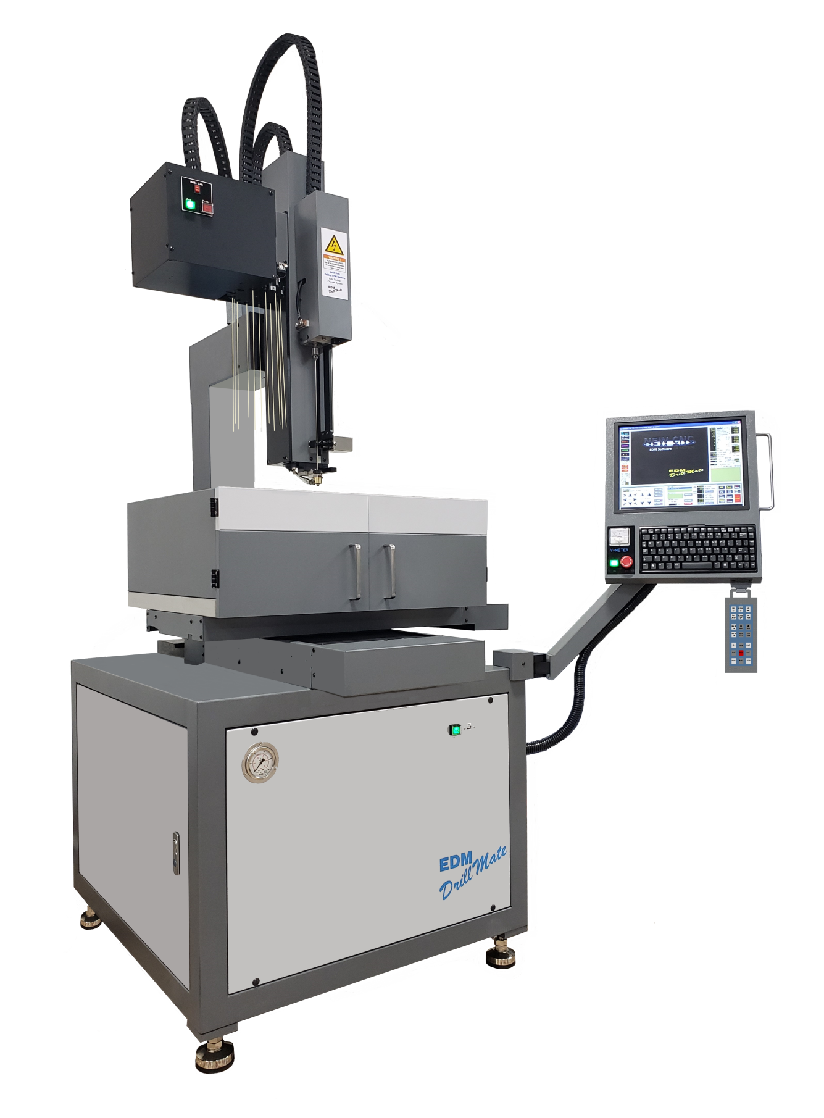

The highlight of the DrillMate 22i-A Series is the small foot print. Also a smooth twelve station carousel electrode changer can be added. The user friendly Windows Based Software will have EDM operators drilling within a few hours.

Included is a robust 60 amp, 75 peak power supply. A solid work piece granite work table aims to protect the table from drilling mishaps. Positioning accuracy is accomplished by linear

guiderails on all three axes with high precision ball screws. Optional time saving features include electrode redress, and tap software for metric and inch threads. Password lock software protects from accidental cutting data changes. Set-up is a breeze with the DrillMate’s hand pendant controller

Designed to meet the needs of JOB SHOPS, AEROSPACE, MEDICAL and DEFENSE INDUSTRIES, the EDM DrillMate 22i-A is a compact, easy to use machine that can find it’s home in almost any shop.

This feature packed machine combines affordability, precision and versatility with a host of standard features along with premium options and accessories. Compare the features and we think you’ll agree... the EDM DrillMate 22i-A offers more than competitive machines that sell for twice the price.

“Designed to put holes in your work, not your wallet!”

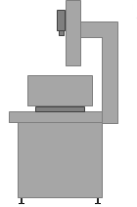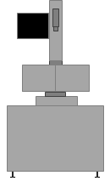

**Granite Work Table**

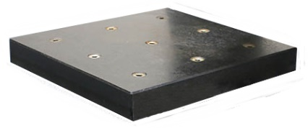

**1.1 Cubic foot resin tank is standard equipment. This larger water tank size provides increased temperature stability for extended dielectric capacity**

63”

52”

97”

**Control / Power Supply**

**Machine Specifications Model 22i-A**

**Table Travels (X-Y)**

**Work Table Size**

**Min. Ram Height to Table**

**W Axis Power Backslide**

**Max. Work Piece Weight**

**Max. Work Piece Height**

**Max. Electrode Length**

**15.75” x 12” x 18.75”**

**21” x 13.5”**

**0.75”**

**19.3”**

**661 lbs.**

**20.0”**

**19.68” (500mm)**

**Peak Current Selections**

**Voltage Selections**

**Pulse On Time Settings**

**Pulse Off Time Settings**

**Servo**

**Maximum Current**

**Gap Adjustment**

**1 - 15**

**2 Steps**

**1 - 30**

**1 - 30**

**1 - 15**

**75 Amp Peak**

**1 - 15**

**Dielectric System**

**Resin**

**Flush**

**Pump**

**Reservoir**

**Filtration**

**Auxiliary Flush**

**1.1 Cubic Ft. Resin Bottle**

**Water / Oil**

**Electric**

**30 Gallon**

**15 Micron / 5 Micron**

**Standard**

**Power**

**Input Power Supply (volts) 3 Phase**

**Max. Power Rating**

**208 / 220 / 240 / 480**

**3KVA**

**General**

**Machine Dimensions (WxDxH) approx.**

**Machine Weight**

**Shipping Dimensions (WxDxH) approx.**

**Shipping Weight**

**63”x 52”x 97”**

**1,500 lbs.**

**73”x 56”x 89”**

**1,600 lbs.**

**Standard Equipment**

**4 Axis Digital Readout**

**3 Precision Chucks (Keyed)**

**3 Pack Brass Electrode Tubes**

**3 Guides**

**LED Worklight**

**Air Hose**

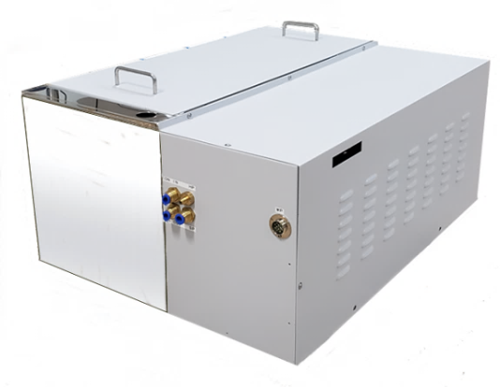

**30 Gallon Filtration Tank**

**The 22i-A offers a smooth operating carousel Tool Changer for quick and efficient continued un-manned operations. The easy clamp system makes changing electrodes user friendly. Automatic mid guides help keep smaller electrodes stable during drilling**

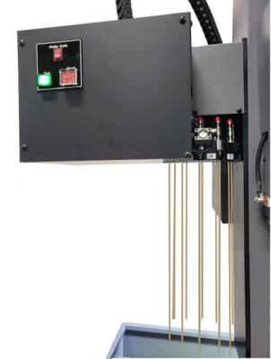

**Automatic Electrode Changer**