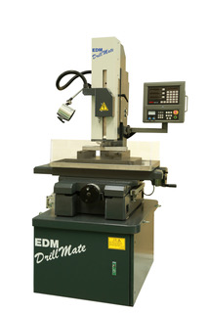

**DM20i Specifications**

X Axis Travel: 13.7"

Y Axis Travel: 9.8”

Z Axis Travel: (Z + W) 14.9” + 11.8”

Min. Ram Height to Table Fixture: .8”

W Axis Power Backslide: 11”

Max. Z Motor Axis Travel with Chuck: 11.2”

Max. Workpiece Weight: 770 lbs.

Max. Workpiece Height: 15.7”

Work-tank Size: 31.5” x 17.7”

Worktable Size: 21.6” x 14.1"

**Dielectric System**

Flush: Water

Pump: ¾ HP

Reservoir: 25 Gallon

Filtration: 5 Micron

**Control/Power Supply**

Program Storage: 100

Peak Current Selections: 8 Steps

Voltage Selections: 1

Pulse On Time Settings: 8 Steps

Pulse Off Time Settings: 8 Steps

Arc Duration: None

Servo: 1 to 8 Steps

Power: 208,220,240,408/3PH/60Hz

Gap Adjustment: 3 Steps

**Control Features**

Auto Retract Audible Edge Finder

Programmable Z Axis Travel First Spark Detection

X, Y, Z Digital Readout Z Axis Forward Progress Status

Divide-by-Two Function High Speed DC Servo System

Inch or Metric Operation

**Power**

Input Power Supply (volts) Three Phase: 208 / 220 / 240 / 460

Max Rating Power: 5 KVA

**General Specifications\***

Machine Dimensions (W x D x H): 40” x 31.5” x 78.7”

Shipping Dimensions (W x D x H): 46” x 40” x 86”

Weight: 2,100. lbs

Shipping Weight: 2,400. lbs

* Dimensions and Weights are Approximate